Wild ‘n Crazy Picasso Portraits
By Cheryl Trowbridge on June 10, 2009 in Uncategorized
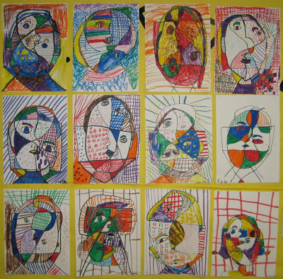“Picasso Portraits”, taught by Mrs. Mendence to her 2nd graders,
after attending my teacher workshop, “Teach Kids Art with Markers”
Nothing beats abstract art for getting kids to loosen up and just have fun with being creative! Not having to worry about making your picture look “realistic” really takes the pressure off, and for many, can be a totally freeing experience!
Pablo Picasso (1881-1973) was a prolific Spanish artist who produced over 20,000 drawings, paintings, prints and sculptures during his 70 year career. As one of the most recognized figures in 20th-century art, Picasso is best known for co-founding the Cubist movement and for the wide variety of styles embodied in his work. Studying his fascinating life and very original art will help both children and adults alike to develop a greater appreciation for all styles of abstract art!
I adapted this lesson from a project I found on Miss Julie’s Place – Art Lessons for Kids. Click here to read her instructions and watch a step-by-step slide show! I chose to teach my lesson a little differently, using markers, bright colors and different types of lines for contrast – rather than focusing just on value, which I think would be a great idea for older kids. Try it both ways!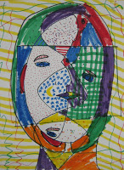
Materials:
9×12 white construction paper
pencil
Magic Rub eraser
Crayola markers in bright colors
Directions:
1. Students may work from a photograph or from life to create their portrait. They may even want to draw Picasso himself!
2. With pencil, draw a large oval shape, filling most of the paper.
3. Next draw a curvy line down the middle of your oval, to simulate the shape (forehead, nose, lips and chin) of a profile-view portrait.
4. Find the lips and draw a sideways “V” shape on both sides, with a line through the middle from corner to corner. You are creating both a profile and front view simultaneously!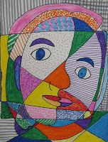
5. Now add the eyes and outline the shapes for the eyebrows above them. Draw only outlines of shapes – nothing filled in yet!
6. Draw a simple “C” or “backwards C” to indicate a nostril on the profile side of your drawing.
7. Add a curved line on both sides of the head for ears and draw the hair as a shape rather than individual lines.
8. Next, draw a “figure 8” (vertically) over the top of your portrait and a rectangle (horizontally) across it. Use these lines to create interesting shapes within your drawing. Erase any lines that create shapes that are too small to color in.
9. Trace over all your pencil lines with a “fine” black Sharpie, then erase any pencil lines that are still showing.
10. Use markers to color each shape, with no two shapes that are next to each other colored the same. Use stippling, hatching, cross-hatching, and even scribbling to fill in your shapes!

