What Inspires You?
By Cheryl Trowbridge on September 28, 2008 in Abstract (Non-representational), Abstract Design, Chihuly, Dale, Drawing, Famous Artists, Inspiration, Oil Pastel, Tips for Teaching Art
While it’s great to follow tried and true plans for a successful Art lesson, it can be fun to come up with a new project on your own, based on something that inspires you. Where do you get inspiration from? It’s different for everyone, but anything that catches your eye (from the shapes and patterns of nature to the shadows cast on the building next door) can offer potential for a great Art experience with your students.
I recently attended an exhibit by world renown glass artist Dale Chihuly at the De Young Museum in San Francisco. The two pictures in this post are of his work, the first a glowing assemblage of vibrant glass forms installed in the ceiling above us and the second a “forest” of colorful glass in a variety of shapes and sizes. (I apologize if my images are blurry, but flash photography is not allowed in the museum….click on the artist’s link to go to his website for better pictures!)
While the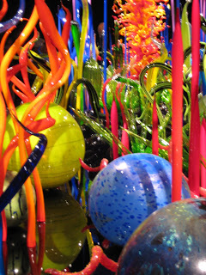 entire exhibit was like a feast of “eye candy”, these two images in particular inspired me with ideas for an abstract Art lesson. They got me thinking about using oil pastels, layered together over black paper, to achieve rich colors in a variety of interesting shapes. I look forward to trying out this idea soon!
So, the next time you see something that just seems to resonate with you, view it as a potential Art lesson! First, consider what it was about it that caught your attention. Then, think about which art medium could best capture this and what principles or elements of Art you can teach through it. And of course, try it out yourself before teaching it to your students! If the thought of all that overwhelms you, simply share your enthusiasm for what you saw with your students! Show pictures if you have them and explain why that particular thing inspired you. Even if it’s just the shadow on the building next door, stop and point it out to your students and discuss it with them. Part of good Art training involves teaching our students to “see like artists” and to really notice and engage with the world around them. Sharing what inspires YOU (whether in the form of an Art lesson or just by pointing it out) is a great place to start!
glass art by Dale Chihuly

