Underwater Fantasy inspired by Paul Klee
By Cheryl Trowbridge on April 29, 2012 in Abstract (Non-representational), Fantasy, Fish / Marine Life, Klee, Paul, Lessons, Mixed Media, Ocean / Seascapes, Painting, Surrealism
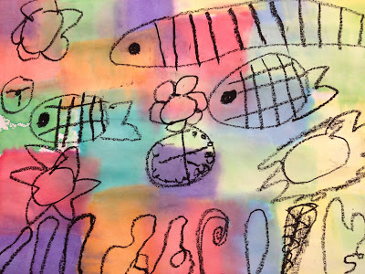
Swiss painter and graphic artist, Paul Klee, is known for his child-like use of line and color…. maybe that’s why kids relate so well to his work! The influence of Surrealism, Expressionism, and Cubism is easily seen in his art, yet he really had a style all his own. This project is inspired by his painting, “Fish Magic”, where he combines traditional underwater imagery with things you wouldn’t expect to see in that setting, such as a clock, a vase of flowers, and a cubist figure waving hello!
Materials:
- 9×12 white construction paper
- black oil pastel
- Spectra “bleeding” art tissue paper (I used the “bright colors” assortment)
- paintbrush and water
- newspaper to protect your work surface, as the color will go right through your paper!
Directions:
1. Using a black oil pastel, draw an underwater scene on your paper (no pencil first – just go for it!). Include typical underwater elements like fish, seaweed and coral.
2. Now, add some things that you wouldn’t normally find underwater…. a clock, flowers, people, etc.
3. Next, lay some squares of “bleeding” art tissue on your paper, and use a paint brush to apply water over the top of the tissue.
4. Repeat step #3, covering as much or as little of your paper with color as you like. Use plenty of water so your tissue will “bleed”! (Note that the color will go right through your paper and onto your work surface, so be sure to put some newspaper underneath it!)
5. Set aside to dry. (Tissue can be removed as soon as the color bleeds through, but it’s much less messy to wait and remove it after it has dried!)
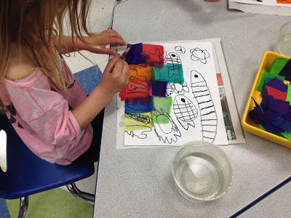
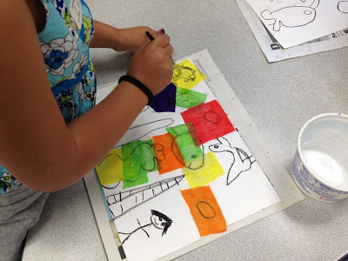
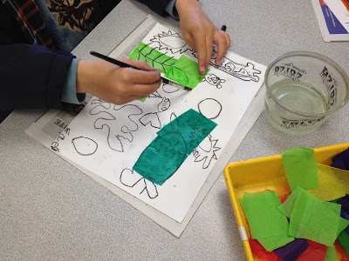
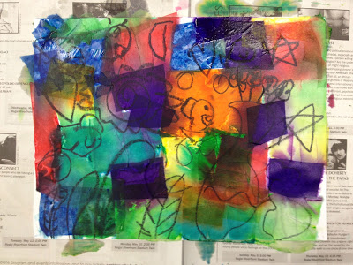
Above is the tissue as it’s drying…..

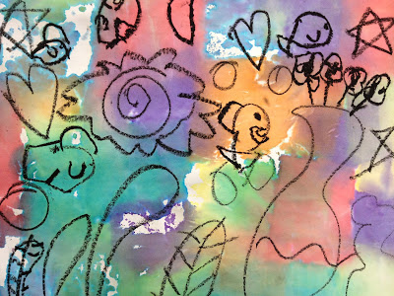
….and here is the finished artwork with the tissue removed. Once the tissue has dried, it simply flakes off. Students LOVE picking the dry tissue pieces off of their artwork!!

