Kandinsky Designs
By Cheryl Trowbridge on March 25, 2010 in Abstract (Non-representational), Abstract Design, Color / Color Mixing, Famous Artists, Kandinsky, Wassily, Lessons, Painting, Tempera
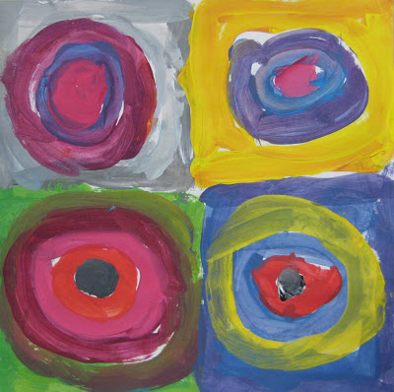I love this color mixing lesson inspired by Russian artist, Wassily Kandinsky! Kandinsky was an accomplished musician as well as an artist, so it’s fun to play music while the students are working. You can do variations of this lesson for just about any grade level. Here is what I do for Kindergarten and 1st grade…. perfect for allowing students to experiment and just have fun with mixing colors, tints, and shades.
Materials:
- 12×12 white construction paper
- Tempera paint: red, yellow, turquoise, white, black
- Water and containers
- Brushes
- Paper plates for palettes
- Paper towels
Directions:
1. Fold your 12×12 paper in half, then in half again so that you have 4 equal squares.
2. Turn on some music to simulate how Kandinsky would listen to music while he painted.
3. Start by painting the perimeter of a section, rounding the inside corners and leaving a white (unpainted) circle inside. Your goal with this project is to mix as many different colors as possible, so keep that in mind as you work.
4. Now, paint four or five circular lines (it’s okay if they’re not perfect circles!) inside that section.
5. Keep mixing new colors, trying not to use the same color in more than one spot. Use all five of your paint colors to mix secondary and intermediate colors, tints, and shades. (Try to rinse your brush only when necessary – you don’t have to rinse it with every color change. After rinsing, dab your brush on a paper towel to remove any excess water.)
6. Continue painting one section at a time in this same way. Keep painting circles until there is no white paper left showing!
