Art Lesson Plans – Abstract Drawing
September 7, 2011 by Elizabeth

Art Lesson Plans – Abstract Drawing
Art lesson plans are inspired by Art History. This abstract drawing lesson was inspired by Piet Mondrian and Geometric Abstraction.
This is a great lesson for the beginning of the school year. The clean up after the abstract drawing art lesson is minimal which helps with classroom management. The class demonstration for this lesson is fun and helps to set a positive mood for art class. This art lesson can be done with all age groups and enables every student to feel success.
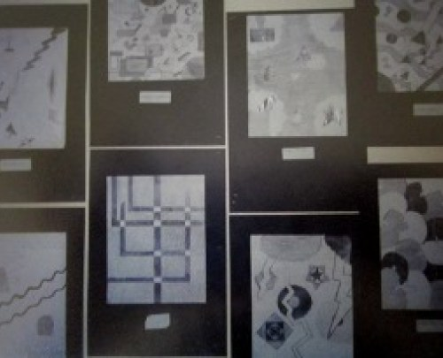
The definition of Geometric abstraction: Art that uses non-representational shapes and lines based on geometric forms to create a composition. There is a purposeful mathematical intent behind each piece of artwork.
Material for Art Lesson:
– Chalkboard, white board or smart board for demonstration
– Letter sized white paper
– Black paper to frame work
– Pencils, erasers, rulers
-Images (Piet Mondrian`s Gray Tree, Mondrian`s Broadway Boogie Woogie, Representational art such as Da Vinci’s Mona Lisa)
Art Lesson Plans Introduction:
Give the definition of geometric abstraction. Use images to help explain the difference between realism (art that represents a real life object) and abstract art and then finally geometric abstraction. The famous image of Da Vinci`s “Mona Lisa” would demonstrate realism or representational art. Mondrian`s “Gray Tree” represents abstract art or a real life object that has been changed or abstracted to Mondrian’s non-objective abstract image “Broadway Boogie Woogie” which is an example of geometric abstract art. Any of Mondrian’s later works would give an example of the movement.
Inspiration and Demostration:
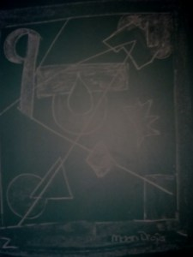
Draw a rectangular box on the chalkboard and choose students to come and draw shapes inside the rectangle one at a time. The students must draw a shape that is geometric and does not represent a real life object. Encourage the students to choose whether they want their shape to be large medium or small and whether they want their shape to be light medium or dark. It is the variety of shades and sizes of shapes that will give their drawing depth of perspective. Each student should make a conscious choice of the size and shade of the shape they add to the design. As the demonstration progresses a conversation on what the class may see in the drawing will arise, which will end the abstract drawing and the class should decide on a name for their geometric abstraction.
Art Lesson plans Application:
Each student should draw two to three small thumbnail abstract drawing sketches in their sketch books or on a extra piece of paper before they begin their abstract drawings on a larger letter sized paper. The thumbnail sketch should be approved on whether the shapes are geometric and non-objective, whether there is a variety of light medium and dark shades and large medium and small shapes. The students can choose the name for their art after they have completed their drawings. It usually takes two classes to complete the project. The demonstration and sketches in the first class and the individual drawings in the second class. students should have rulers and erasers in class to complete the drawings.
Display:
The students abstract drawing should be glued or taped onto a black paper with a name tag placed under the drawing with the name of the artist and the name of the piece of art.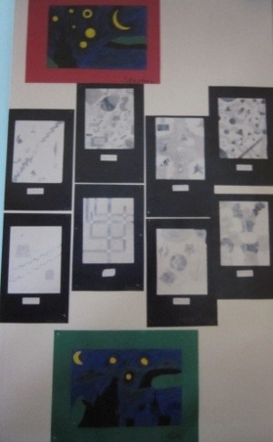
Curriculum Expectations for Grade Six
Overall: Creating and Presenting: apply the creative process to produce art works in a
variety of traditional two- and three-dimensional forms
Specific: Use elements of design in art works to communicate
ideas, messages, and understandings

Geometric Abstraction Piet Mondrian
September 7, 2011 by Elizabeth

Geometric Abstraction Piet Mondrian
When we think about abstract art we think about shapes and designs that do not represent real life objects. There are many sub-categories under the term abstract art and the one with the strictest rules is Geometric Abstraction. Geometric abstraction is art that uses non-representational shapes and lines based on geometric forms to create a composition. There is a purposeful mathematical intent behind each piece of artwork.
In the 20th century artists like Wassley Kandinsky and then Piet Mondrian who followed the De Stijl movement opened modern artists to the idea of purely communicating through shape and designs. Some artists like Mondrian became purists and used only the primary colors red, yellow and blue. He described the primary colors as true colors.
Looking at two of Mondrian`s paintings we can clearly see the difference between Geometric Abstraction (Broadway Boogie Woogie) and other abstract art movements such as Cubism (Gray Tree).
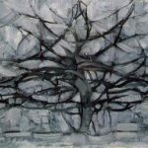
Piet Mondrian, Gray Tree 1912
This is an example from his early works that still holds representational qualities. The real tree is abstracted with shapes or planes of color and shadows to create the composition.

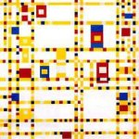
Piet Mondrian, Broadway Boogie Woogie 1942 -1943
In this geometric abstraction Mondrian is fully immersed in the geometric abstract style using shapes and lines to evoke a feeling and sentiment. The title of this painting is key to helping the viewer identify the artist`s intent.

