Alphabet Art
By Cheryl Trowbridge on February 17, 2009 in Abstract Design, Drawing, Johns, Jasper, Lessons, Lettering, Markers / Pen and Ink, Pop Art, Words / Letters
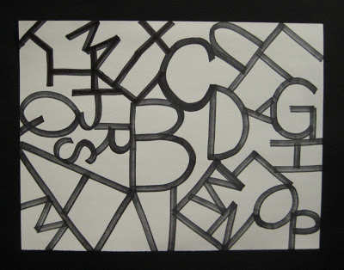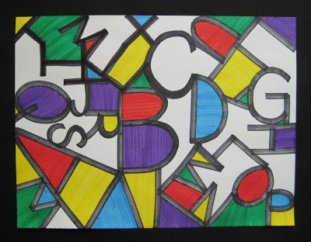
In today’s culture, some symbols have become so familiar that we’ve stopped noticing them. This idea is what prompted contemporary American artist, Jasper Johns, to create abstract paintings from symbols such as letters, numbers and maps to get his viewers to experience these symbols in new ways.
Your students can follow these steps to share this experience and learn about abstract art with this fun project!
1. Choose a theme for your design. Possible choices could be upper case letters, lower case letters, numbers or a mix of all three.
2. Using a pencil, lightly sketch your letters or numbers, working large but varying the sizes and angles, to fill your entire paper. Each letter or number should randomly connect to another letter or number so that you create new shapes (“negative spaces”) in the areas around them.
3. Trace over your pencil lines with a permanent, black chisel-tip marker, to create thick, solid lines.
4. Now use brightly colored markers to fill in the new shapes created around your letters or numbers. You may choose to fill in some of the shapes or all of them. (Remind students to color all one direction within each shape to avoid a “scribbled” look.)
Have fun experimenting with variations on this project, using names, phrases, dates, etc. I’ll be trying this project tomorrow with 1st graders…. I’ll let you know how it goes! :)

