**An Abstract “Musical Composition”!**

By [Cheryl Trowbridge](http://www.teachkidsart.net/author/Cheryl/) on March 9, 2011 in [Drawing](http://www.teachkidsart.net/category/process/drawing-lessons-by-process/), [Elements of Art](http://www.teachkidsart.net/category/subject/elements-of-art-lessons-by-subject/), [Lessons](http://www.teachkidsart.net/category/lessons/), [Oil Pastel](http://www.teachkidsart.net/category/medium/oil-pastel-lessons-by-medium/)

[](https://lh6.googleusercontent.com/-vOzm4Ocp4yY/TXhaGp2L6EI/AAAAAAAABjI/DcAd_Qosx0g/s1600/IMG_6374.JPG)

*Abstract art is a great way to teach composition and the* [*Elements of Art*](http://arthistory.about.com/cs/reference/f/elements.htm)*… without the intimidation that can occur when striving for realism.  Take some musical symbols and create a random layout… and have fun with it!!*

**Materials**:

* 12×18 black construction paper
* Oil pastels *(we used the Pentel 16 color set)*

[](https://lh5.googleusercontent.com/-ei1uOU1pZGE/TXhaFgY2BkI/AAAAAAAABjE/F3CL_4XyvRI/s1600/IMG_6373.jpg)

**Directions:**

1. Sketch your design using a white oil pastel.  Include at least 3 or 4 musical elements, overlap them and crop some of them, letting the edges go right off the page!  Avoid lines that go into the corners or divide your paper down the middle.  Try to keep your composition balanced, so that one area isn’t over-loaded and another area empty.

2. Notice how the overlapping elements create new shapes in the background.  Color each of those shapes differently!  Always layer your oil pastels… for example, you might lay down a light blue, then a darker blue, then finish with some white on top.  Try to have at least two layers of oil pastel everywhere, for the richest, most interesting colors.  Play *“hide the black paper”* – don’t leave any areas of plain paper showing!

3. Finally, outline with black to make your design really pop!

[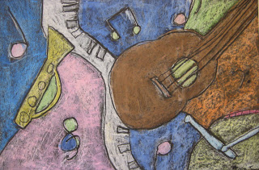](https://lh5.googleusercontent.com/-T09KygCjv90/TXhaIEUMmzI/AAAAAAAABjM/SQOPvos3n_0/s1600/IMG_6377.JPG)

[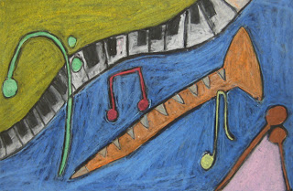](https://lh6.googleusercontent.com/-er9VVdCHgsU/TXhaI2jKQqI/AAAAAAAABjQ/CWfKAEfGNEw/s1600/IMG_6382.jpg)