**Abstract Design with Markers**

By [Cheryl Trowbridge](http://www.teachkidsart.net/author/Cheryl/) on June 15, 2009 in Uncategorized

[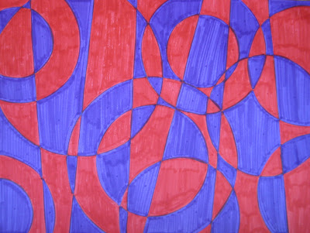](http://4.bp.blogspot.com/_OvkXlKyAmo0/SjbJqCrXckI/AAAAAAAAAo0/uf61mB49V5A/s1600-h/IMG_1821_2.JPG)

*This project offers a great opportunity to introduce the work of abstract artists* [***Robert & Sonia Delaunay***](http://images.google.com/images?q=robert+and+sonia+delaunay&oe=utf-8&rls=org.mozilla:en-US:official&client=firefox-a&um=1&ie=UTF-8&ei=mdQ2SrH1HJGgswPsmsCmDg&sa=X&oi=image_result_group&resnum=1&ct=title)*. I first saw this idea almost 20 years ago – I have no idea where I got it from, but I’ve used it almost every year since then and its always been a hit! The results are consistently amazing!!*

**Directions:**

1. With your paper laid horizontally in front of you, draw 6 straight lines (in pencil) from top to bottom, vertically or diagonally, but *not crossing* each other.

2. Next, draw circles over these lines, overlapping each other and sometimes going right off the page. (We used plastic lids recycled from yogurt and sour cream containers, etc., but you could also use a compass to draw your circles.) Focus on creating interesting shapes and a balanced composition, but *avoid creating shapes that are really small.*

3. Now choose two contrasting colors (or one color plus white) and color your design in an *alternating pattern*. Working vertically, color one “column” at a time. Begin with the shape in the top left corner and work your way down the first column, alternating your colors as you go. When your first column is complete, move on to the next one, making sure to alternate your colors from left to right as well as top to bottom, so that *matching colors only touch at the corners!* Work from top to bottom, left to right, one column at a time until your design is completely colored in.

You can also try this project with other shapes in addition to circles, just make sure you start by creating your vertical “columns” first! *The biggest challenge with this project is to avoid having any two shapes with the same color touch each other, other than at their corners. The trick is to* ***color methodically****, working top to bottom and left to right, one “column” at a time! Sometimes placing a small dot of the appropriate color in each section before filling in the whole area can help to avoid “accidents”!*

[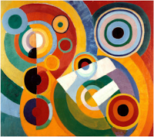](http://4.bp.blogspot.com/_OvkXlKyAmo0/SjbXPrzdURI/AAAAAAAAApk/RaGo-gb6euU/s1600-h/Picture+2.png) [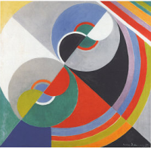](http://4.bp.blogspot.com/_OvkXlKyAmo0/SjbXb4wE8cI/AAAAAAAAAps/2L_cgA7jPPc/s1600-h/Picture+3.png)

*“Rhythm, Joy de Vivre” by Robert Delaunay   
and “Rythme Colour I” by Sonia Delaunay*

*Robert Delaunay (1885-1941) and Sonia Delaunay (1885-1979) were husband and wife artists (from France and Russia, respectively) who co-founded the* [***Orphism***](http://www.britannica.com/EBchecked/topic/433206/Orphism) *art movement, known for its strong colors and geometric shapes. Their work, which included painting, large murals and stage set design, often looked strikingly similar to each other’s. Sonia outlived her husband by many years and went on to design dresses, fabrics and interiors.*